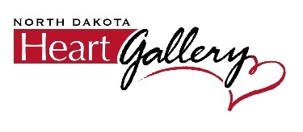

Dear Volunteer Photographer,
Please accept our sincere gratitude for volunteering to be a photographer for The North Dakota Heart Gallery! This effort would not be possible without the generous contributions of talented and compassionate individuals like you.
Your signed agreement allows us to maintain your contact information and reach out to you if a child we serve resides near your business location. Our goal as an organization is to raise awareness of the need for adoptive families for children who do not have an adoptive home. Once a child is referred to the North Dakota Heart Gallery, they are provided with funds to select a new outfit of their choice for their personal photoshoot--- they often make choices that highlight their unique spirit and personality! Following their shopping experience, a photoshoot is scheduled, and this is where your support and talent is needed. In coordination with a child’s legal custodian, adoption worker, or foster parent, a photo session will occur in an effort to generate photos that reflect each child’s personality. Photos will then be highlighted throughout the communities of North Dakota with hopes of matching each child with an adoptive home!
Please read, sign and return this document to Lizzy LaFond at Lizzy.LaFond@ndheartgallery.org. If you have any questions, don’t hesitate to reach out!

Kindest regards,

Lizzy LaFond
North Dakota Heart Gallery

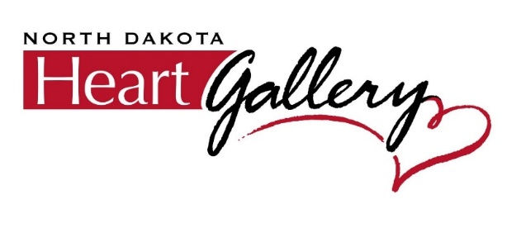
Photographer’s Release
I, ___Tina M Klefstad _, the undersigned, as a volunteer photographer for the North Dakota Heart Gallery (“NDHG”), agree to the following statements:
- I understand that I am providing a charitable service to NDHG for the purpose of photographing children who are in need of an adoptive family. I understand I will not be financially compensated for this service.
- I understand that I agree to be in compliance with all North Dakota State regulations concerning the privacy of these children.
- I, under penalty of perjury, certify that I am not a convicted felon, nor under suspicion of committing a felony, in the State of North Dakota or in any other state or principality.
- I understand that I cannot use the photographs or any representation of these photographs for any other purpose, to include, but not limited to, advertising, portfolios, websites or displays.
- I understand that I must keep confidential any information that I might learn of these children, including (but not limited to) a child’s current residence, date of birth, last name, school, or any other identifying information.
- I understand that the NDHG may use the photographs I have taken, without further permission from me, for any use deemed appropriate by the aforementioned entities. I understand that, where possible and feasible, I will be given credit for the photographs I have taken.
- I understand that I cannot hold NDHG, or any representative or contractor (including the North Dakota Department of Health and Human Services Children and Family Services, North Dakota Human Service Zones, Catholic Charities North Dakota/Adults Adopting Special Kids or All About U Adoptions) liable for any accident or injury to me or to my property or to my business that might occur while photographing the child(ren), or as a result of publication or display of the finished portrait(s).
- I understand that my agreement to photograph above-mentioned child(ren) is also an agreement to take photographs that, to the best of my ability, highlight the child(ren), fully understanding that the purpose of these photographs is to enable “heart connections” to be made with prospective adoptive families. I agree that if a choice must be made between highlighting my artistic skills, and highlighting a child’s personality, I will choose to highlight the child’s personality.
- I understand that given the nature of this endeavor, I am given no guarantee that my photograph(s) will be displayed. I understand that there are reasons beyond my control for which a photograph might not be displayed, to include adoption before release of the photographs, or a change in the child’s status.
- I understand that I must not photograph any other children who might accompany the designated child(ren) during the photo shoot, as they may be foster children who do not have a media release to be photographed.
- I understand that NDHG may edit the photograph(s) for sizing, lighting, contrast, and other reasons, as deemed appropriate by NDHG personnel, without further permission from me.
- I understand that if I choose to write a short paragraph about my experiences with the child(ren) as a supplement to the photograph(s), I am turning over the rights of publication of those words to NDHG, to be edited, as deemed appropriate, to best highlight and protect the child(ren).

I understand that all items on this agreement shall be forever binding. Should I wish to end my volunteer services with the North Dakota Heart Gallery, I will do so in writing and send to the North Dakota Heart Gallery Director via mail or email.

Photographer’s Signature: Tina M Klefstad owner/operator

Date: 9/18/2025
Studio Name: Tina March Photography

Phone: (_701 ) 649-6428
Studio Address:_10638 24th St NE
Pekin ND 58361

